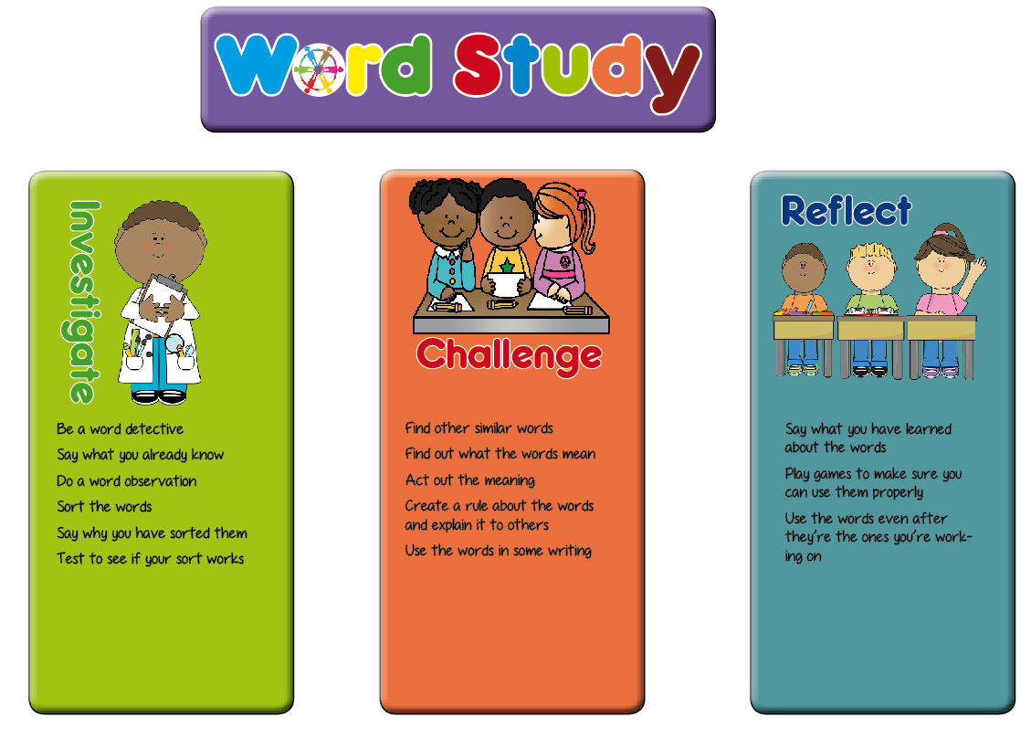**Year 2 Planning Ideas**

In Key Stage One, we have planned a range of generic activities which fit in with the word study teaching sequence. These are a suggestion for ideas which will generate talk for spelling activities and promote enquiry and discussion of the way words work among the pupils.

Hopefully these ideas will be a springboard for the activities you plan in your classroom.

|  |  |  |
| --- | --- | --- |
| **Investigate** | **Challenge** | **Reflect** |
| * Say what they know about the words (modelling) * Soundtalk the words * How many phonemes are there in the word? * Are there long or short vowels in the word? * How many syllables are there in the word? * Look for small words in the whole words * Look at the shape of the words * Look at what the words mean * Do a word sort (see the word sort resources section of the web site) * Say why they have sorted the words in the way they have * Explain what they think the spelling rule sort is | * Explain to someone else how to do the word sort * Finger spy or magnifying glasses to find words that are similar (visit other classes, stuck around the room, in the garden, in their reading books) * Find out what the new words mean (using dictionaries, ask someone at home) * Can you act the words out? * Explain how to use the words * Can you put the words in a sentence? * Can you find other words with the same pattern to add to your word sort? | * Play hangman with the words * Play bingo with words * Play snap with words * Build with magnetic letters (could be timed) * In pairs, take turns to spell the words * Spelling investigation writing – use different colours * Have a poster area for children to add words to the word sort as they find them in their reading |

**This list of tasks for spelling is taken from the planning structure at Shakespeare and More** [**www.shakespeareandmore.com/spelling.html**](http://www.shakespeareandmore.com/spelling.html)

|  |  |  |
| --- | --- | --- |
| **Spring Term Year 2 list** | **Teaching Guidance** | **Word List** |
| **To /r/ sound spelt wr at the beginning of the word.** |  | Shakespeare and More list 9  write, written, wrote, wrong, wrap |
| **The /l/ or /əl/ sound spelt –le at the end of words** | The –le spelling is the most common spelling for  this sound at the end of words. The preceding consonant is doubled if the vowel  before it is short, but single if the vowel before it is long. (if there are 2 different consonants none need doubling regardless of vowel length) | table, apple, bottle, little, middle |
| **The /l// sound spelt –le at the end of words** | The –el spelling is much less common than –le.  The –el spelling is used after m, n, r, s, v, w and  more often than not after s. | camel, tunnel, squirrel, travel, towel, tinsel |
| **The /l/ or /əl/ sound spelt –al at the end of words** |  | metal, pedal, capital, hospital, animal |
| **/ɔ:/ spelt a before l and ll** | The /ɔ:/ sound (“or”) is usually spelt as a before l and ll.  Letters and Sounds Phase 5 | pencil, fossil, nostril  all, ball, call, walk, talk, always |
| **Common exception words** | everybody, even, great, break, steak, pretty, class, grass, pass, plant, path | |